Instructor Mukhtiar Zamin
Muzammil Ahmed
Fa22-bse-038
News app

Use Case Diagram:

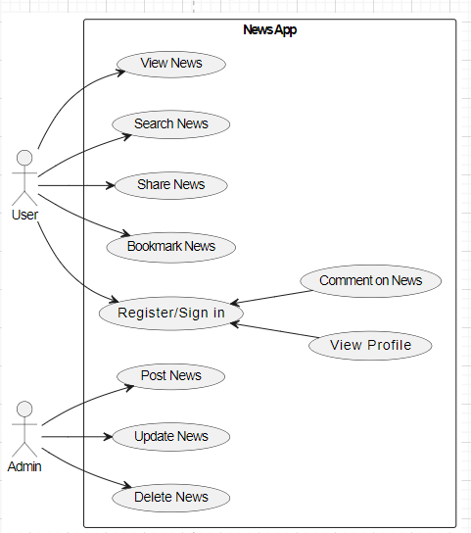

Fully dress USECASE Diagram(View News):
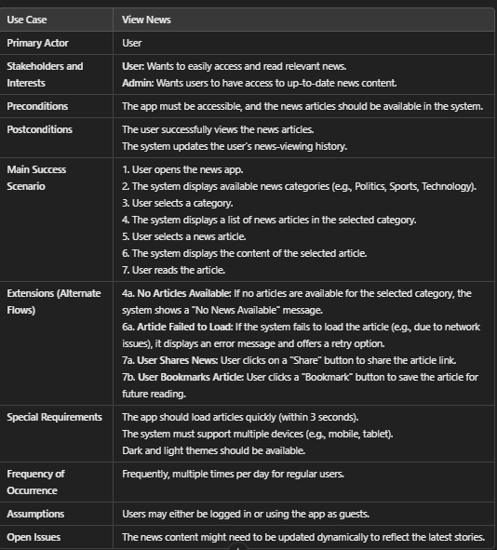

System Sequence Diagram:

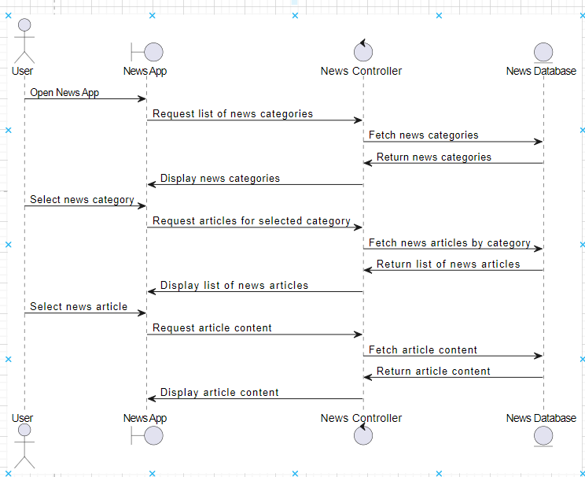

Class Diagram
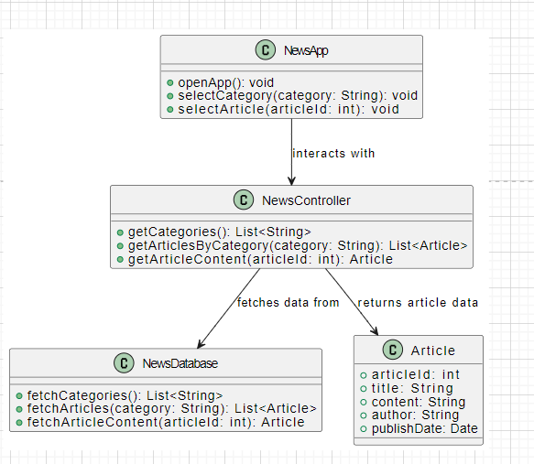

Composition Diagram:
